Module 7: DynamoDB Assignment
Problem Statement: You work for XYZ Corporation. Their application requires a database service that can store data which can be retrieved if required. Implement a suitable service for the same.
While migrating, you are asked to perform the following tasks:
1. Create a DynamoDB table with partition key as ID.
2. Add 5 items to the DynamoDB table.
3. Take backup and delete the table

Creating the table:
Name: Employee
Partition key: EMP-ID
Sort key: Dept
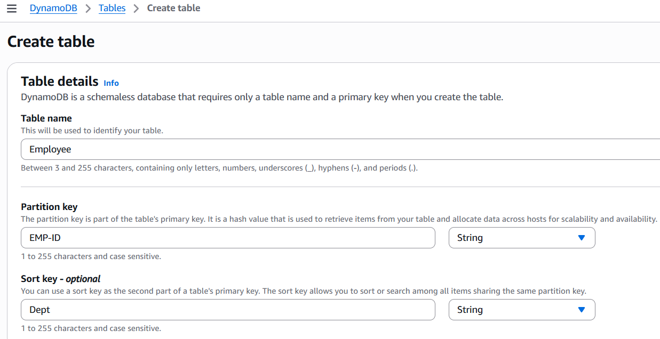
Creating under Customized setting and Standard table class:
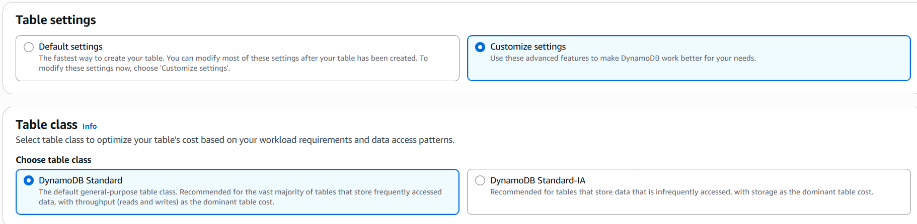
Setting capacity parameters:
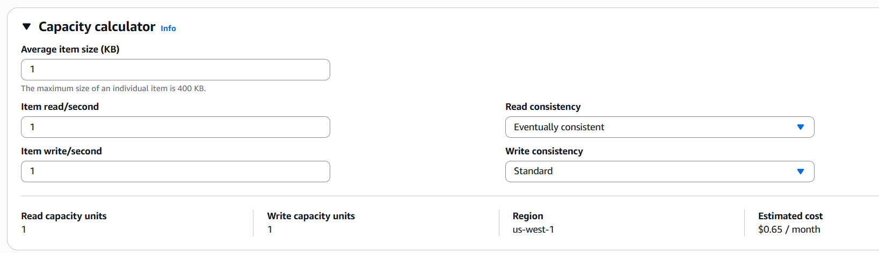

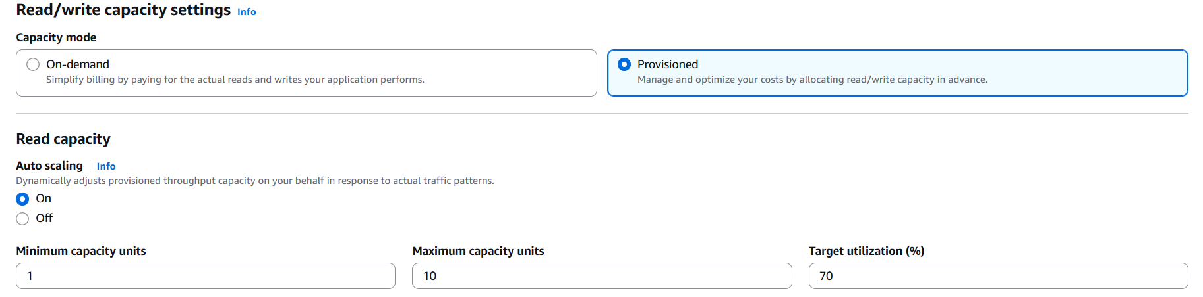

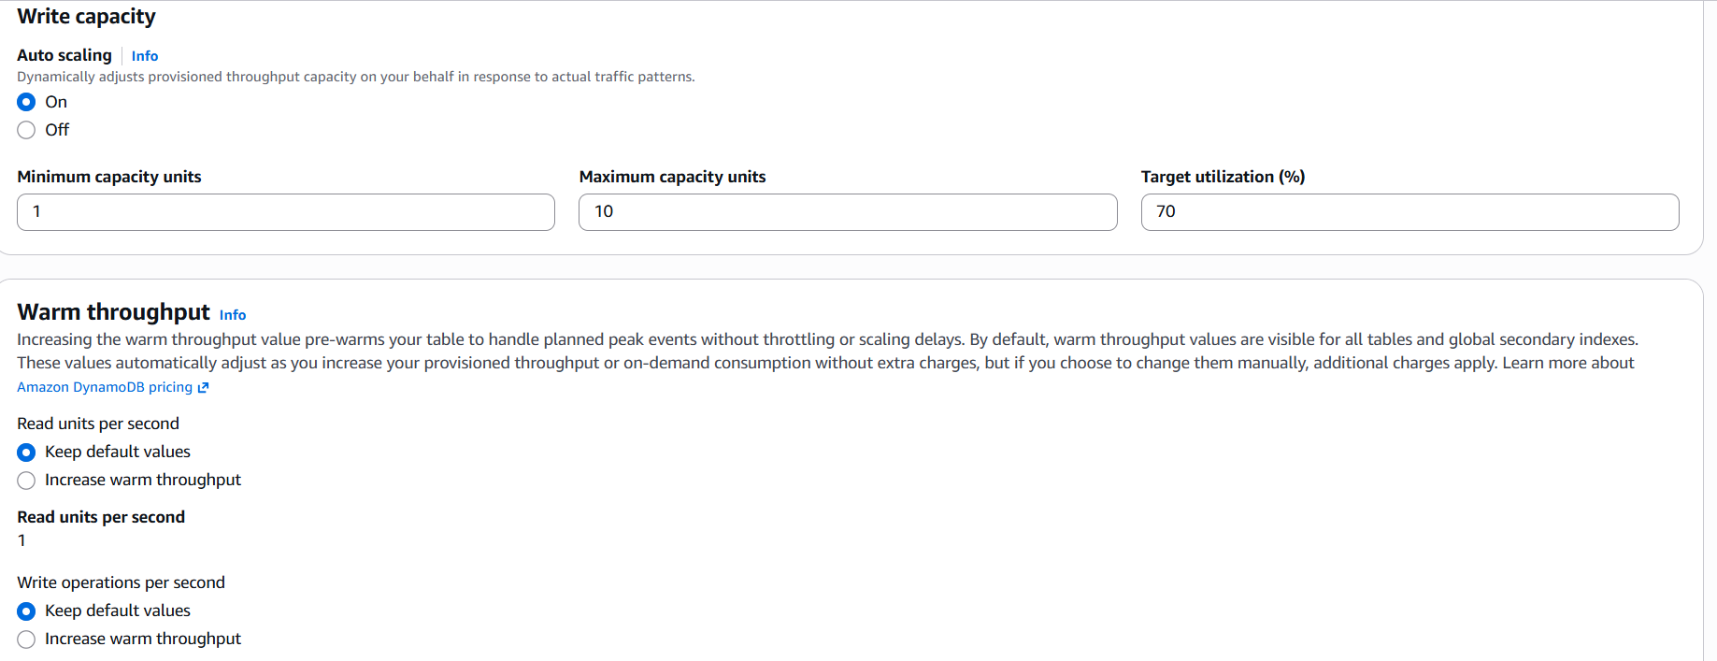

Creating Local secondary index (as it can be created during table creation only):
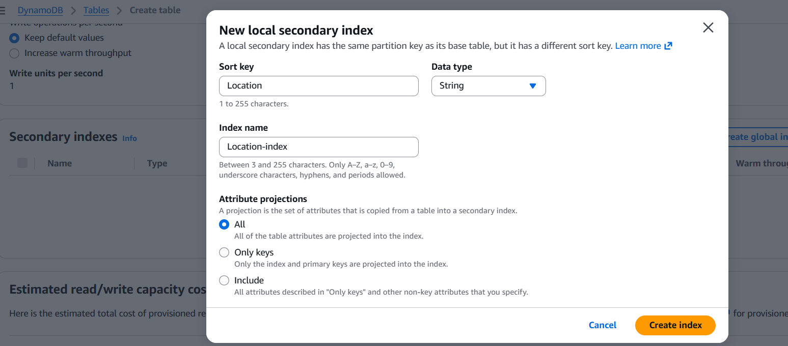

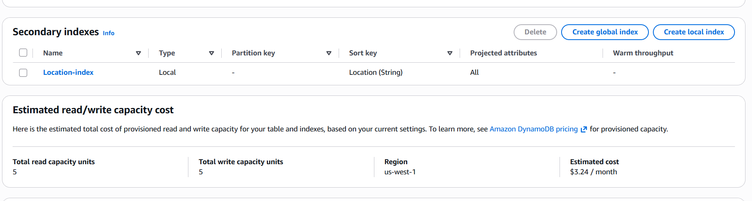
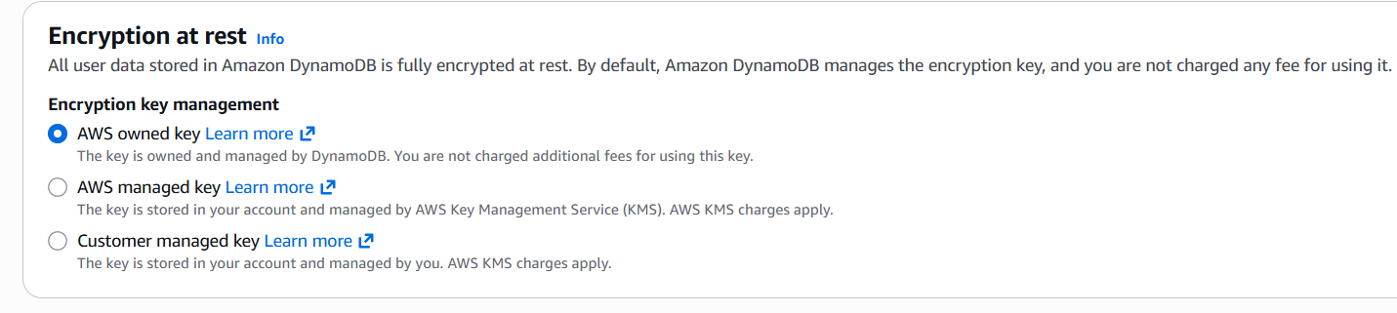

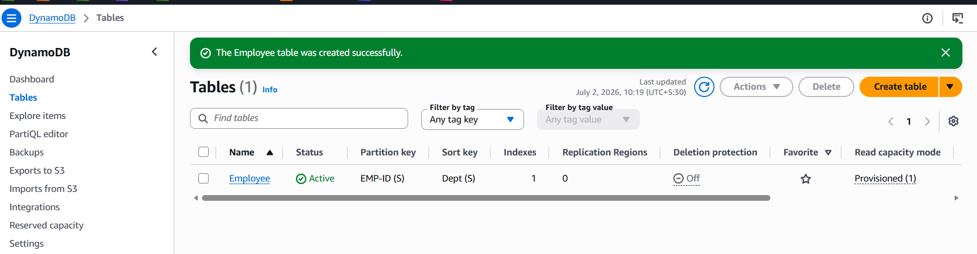
Creating the items under Explore table items:
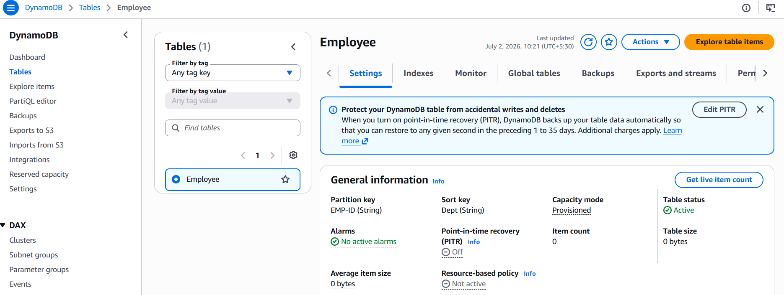

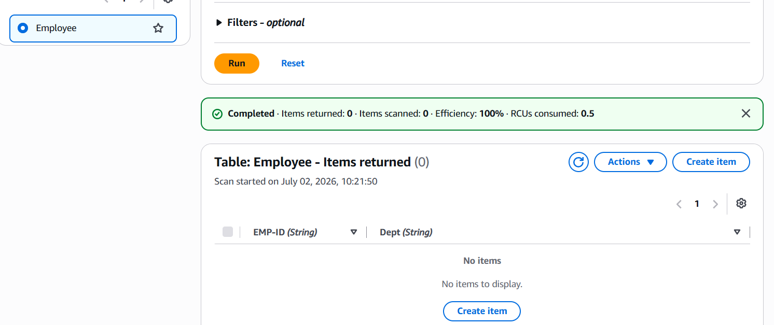

Adding new attribute Name along with the existing attributes:
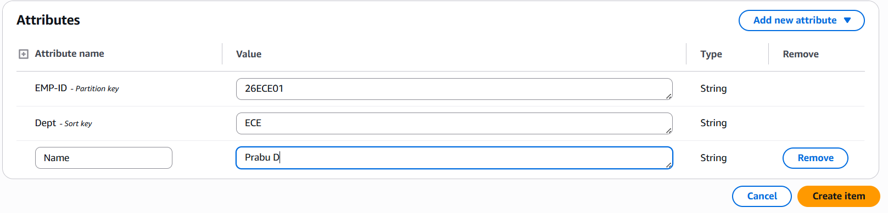

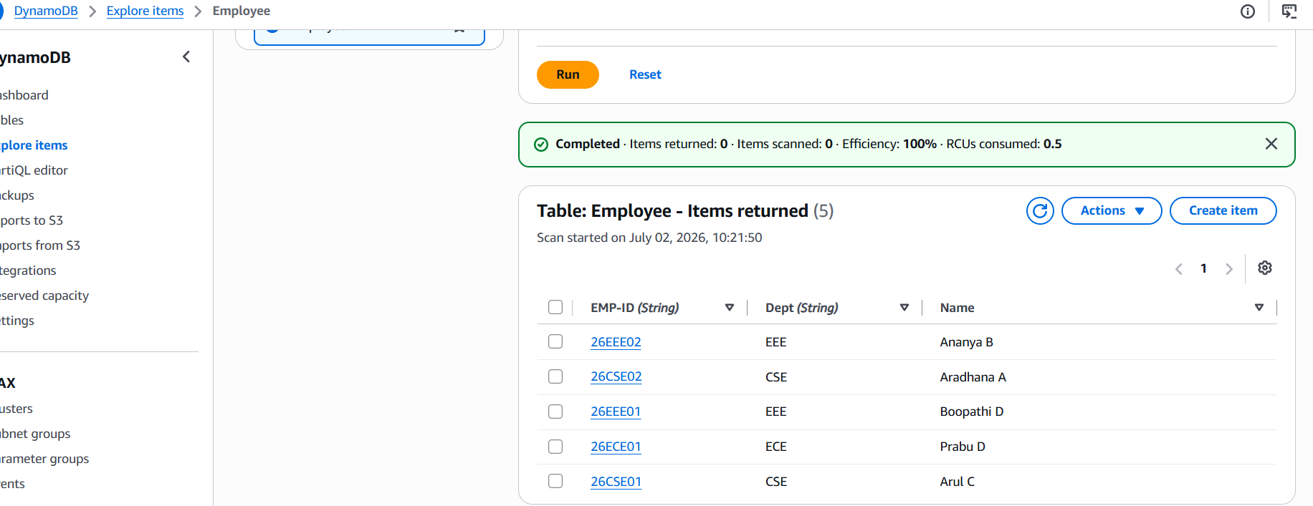

Creating Backup under backup tab:
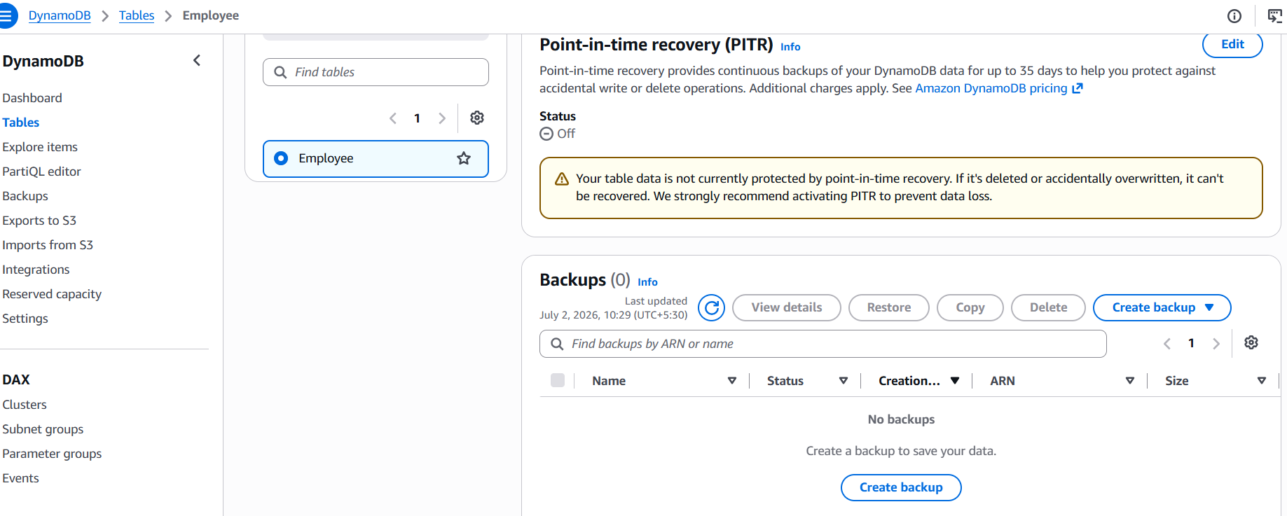

Selecting on-demand backup:

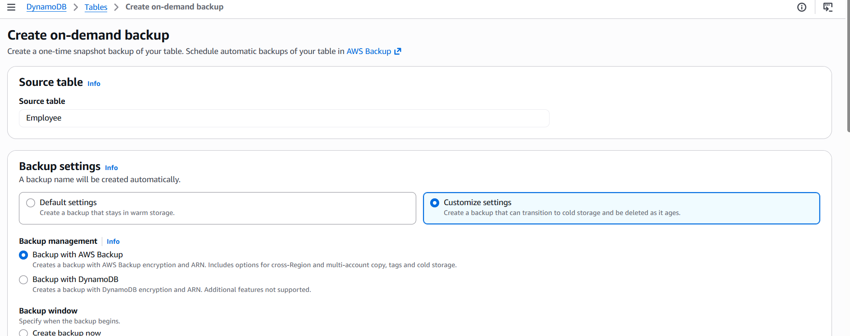

Selecting the backup start time & retention period:
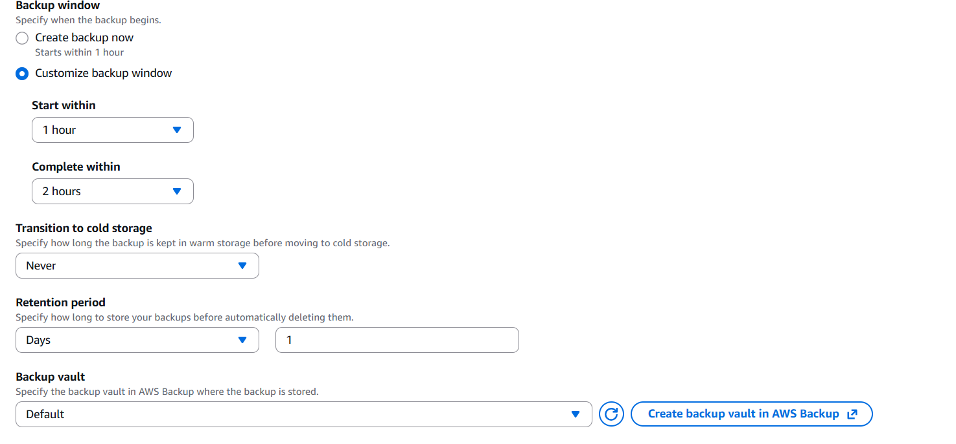

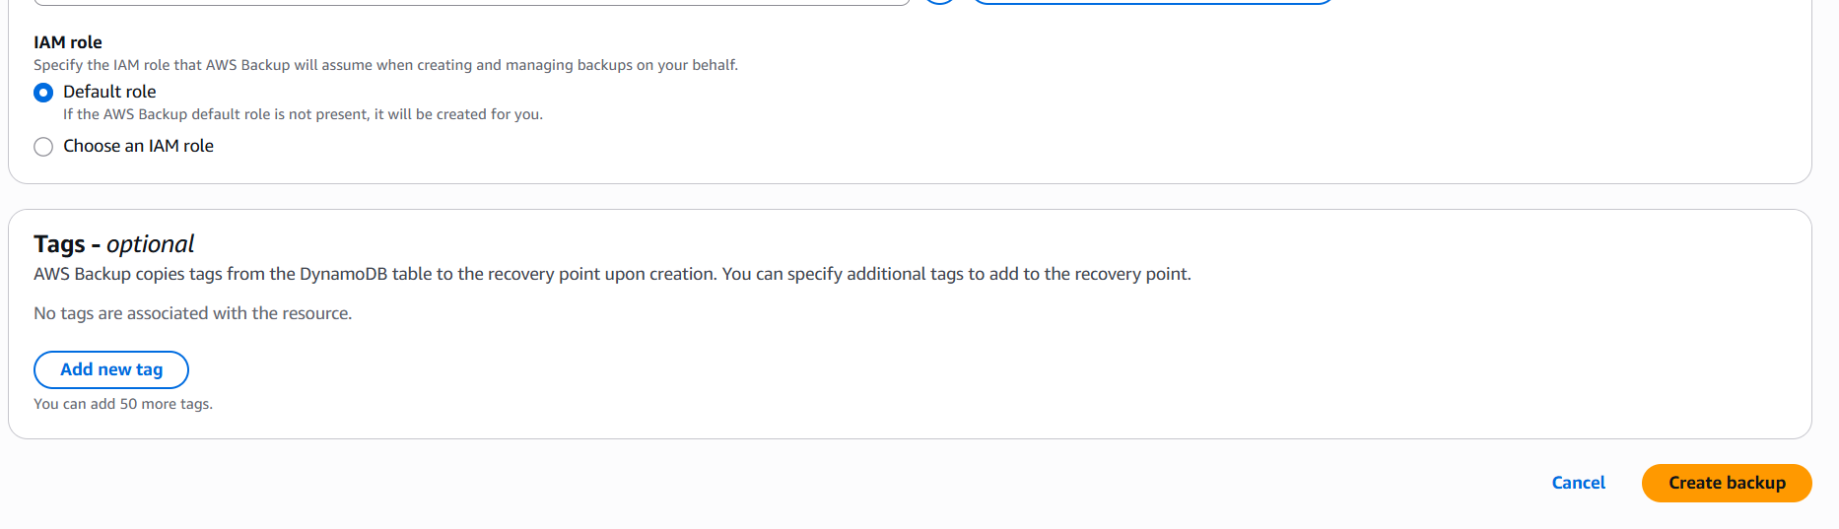

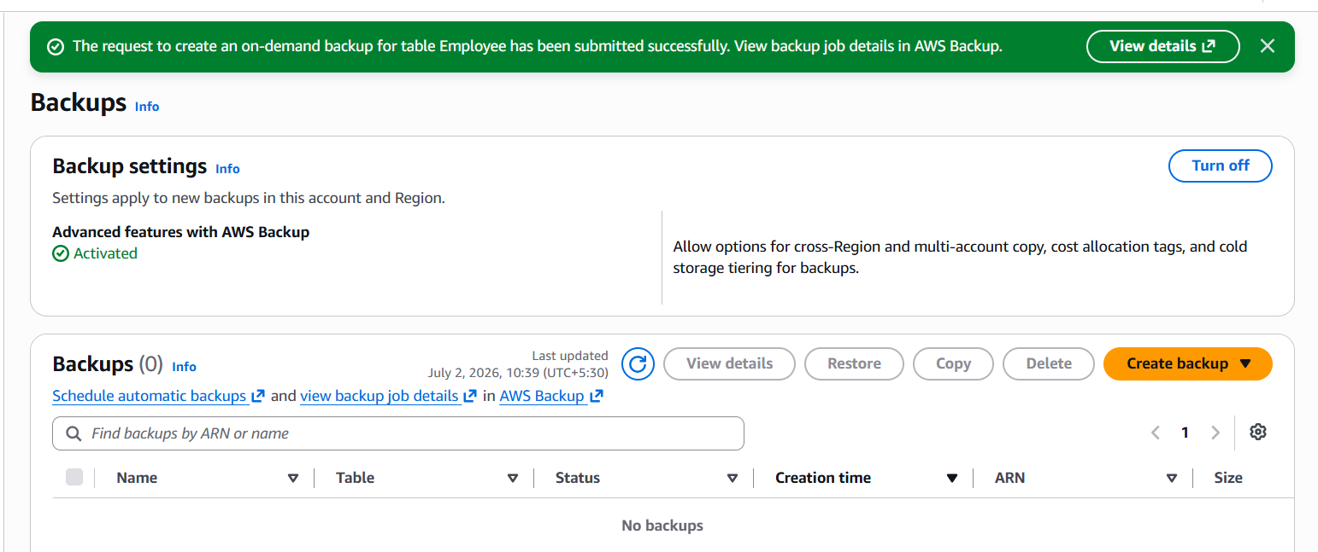

Backup created under AWS Backup service:
Backup ID: Backup - a0af1be2-5a56-43b9-b8f7-97cfb2d29065

Status: Running
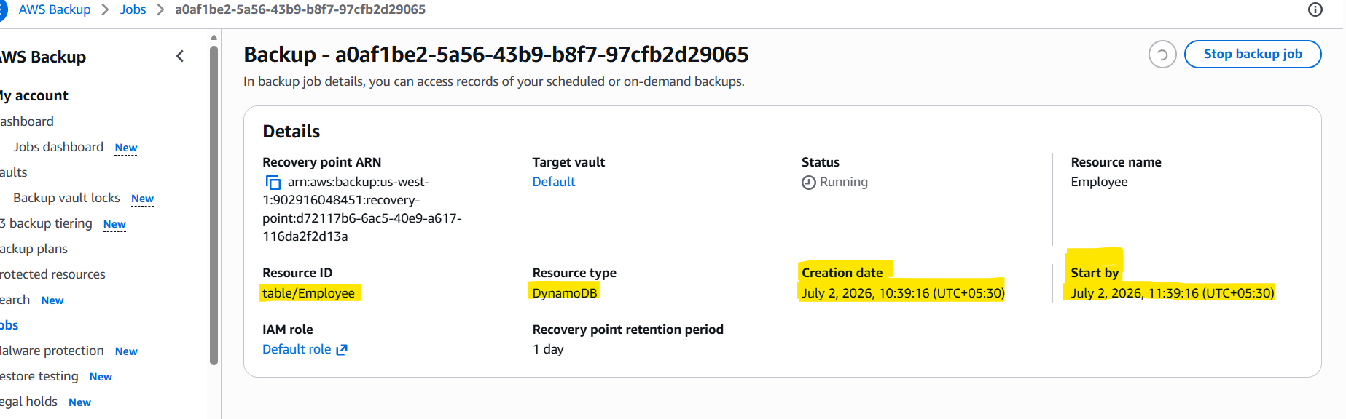
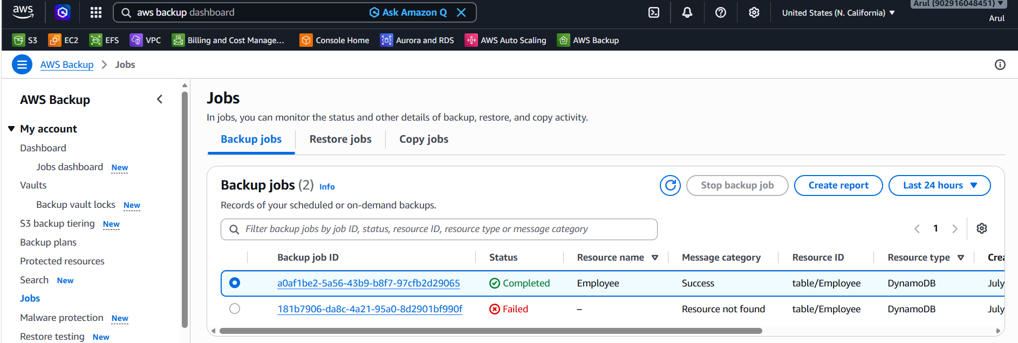

Status: Completed
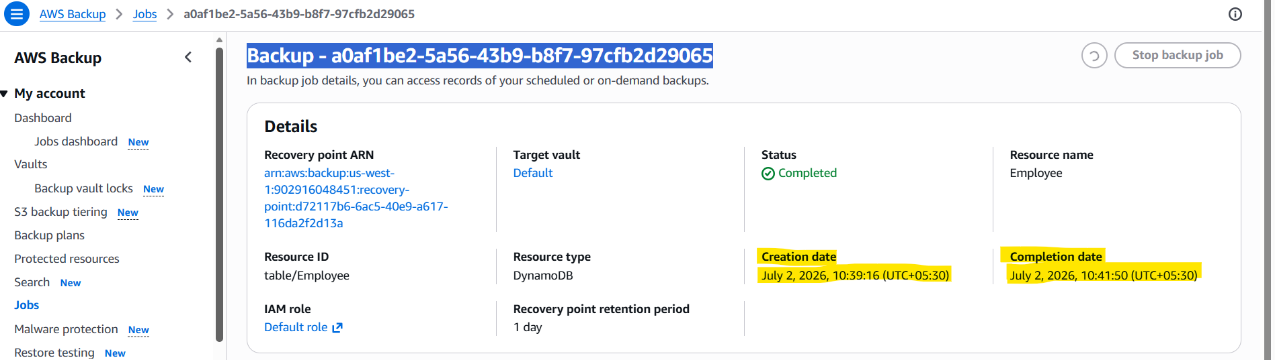

Backup created under DynamoDB:
ID: Backup: d72117b6-6ac5-40e9-a617-116da2f2d13a
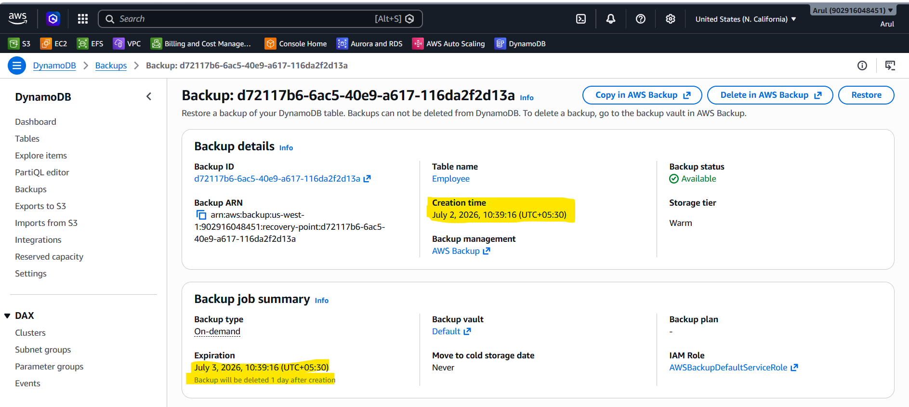

Deleting the table:
